**Assignment 4**

**Sejal Gupta**

**22BCS10298**

**FL_IOT_603 A**

**1763.**[**Longest Nice Substring**](https://leetcode.com/problems/longest-nice-substring/description/)

class Solution {

public:

    string longestNiceSubstring(string s) {

        if (s.size() < 2) return "";

        unordered_set<char> st(begin(s), end(s));

        for (int i = 0; i < s.size(); i++) {

             if (st.find((char) toupper(s[i])) == end(st) || st.find((char) tolower(s[i])) == end(st)) {

                string s1 = longestNiceSubstring(s.substr(0, i));

                string s2 = longestNiceSubstring(s.substr(i + 1));

                return s1.size() >= s2.size() ? s1 : s2; } }

        return s;  }

};

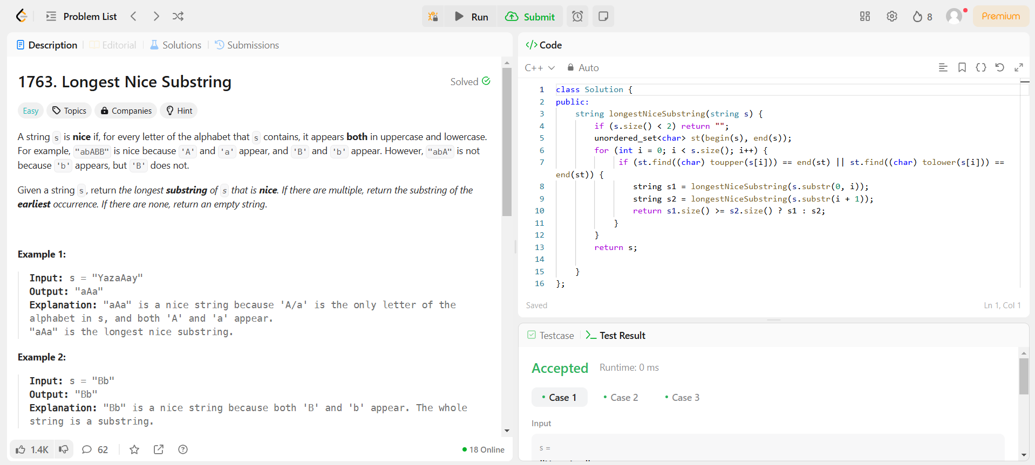

**190.**[**Reverse Bits**](https://leetcode.com/problems/reverse-bits/description/)

class Solution {

public:

    uint32_t reverseBits(uint32_t n) {

        string bits = bitset<32>(n).to_string();

        reverse(bits.begin(), bits.end());

        int ans = stoll(bits, NULL, 2);

        return ans;

    }

};

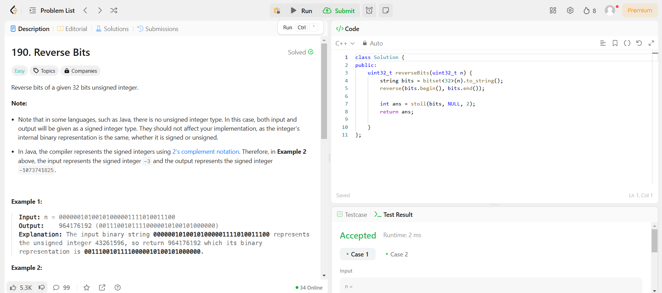

**191.**[**Number of 1 Bits**](https://leetcode.com/problems/number-of-1-bits/description/)

class Solution {

public:

    int hammingWeight(int n) {

        int count = 0;

        for(int i = 31; i >= 0; i--){

            if(((n >> i) & 1) == 1)

                count++;

        }

        return count;

    }

};

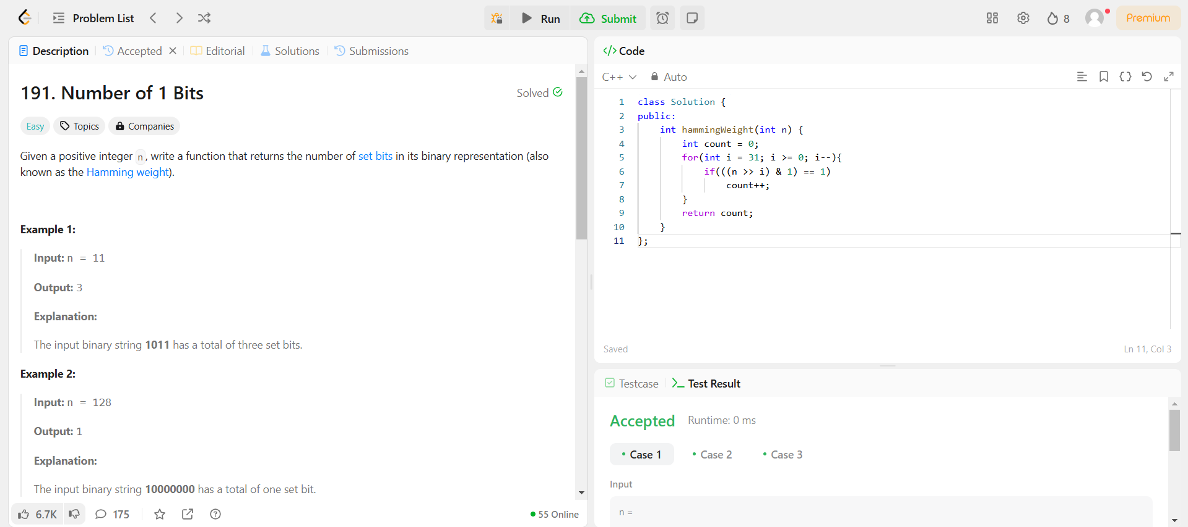

**53.**[**Maximum Subarray**](https://leetcode.com/problems/maximum-subarray/description/)

class Solution {

public:

    int maxSubArray(vector<int>& nums) {

        int maxSum = INT_MIN;

        int currentSum = 0;

        for (int i = 0; i < nums.size(); i++) {

            currentSum += nums[i];

            if (currentSum > maxSum) {

                maxSum = currentSum;

            }

            if (currentSum < 0) {

                currentSum = 0;

            }

        }

        return maxSum;

    }

};

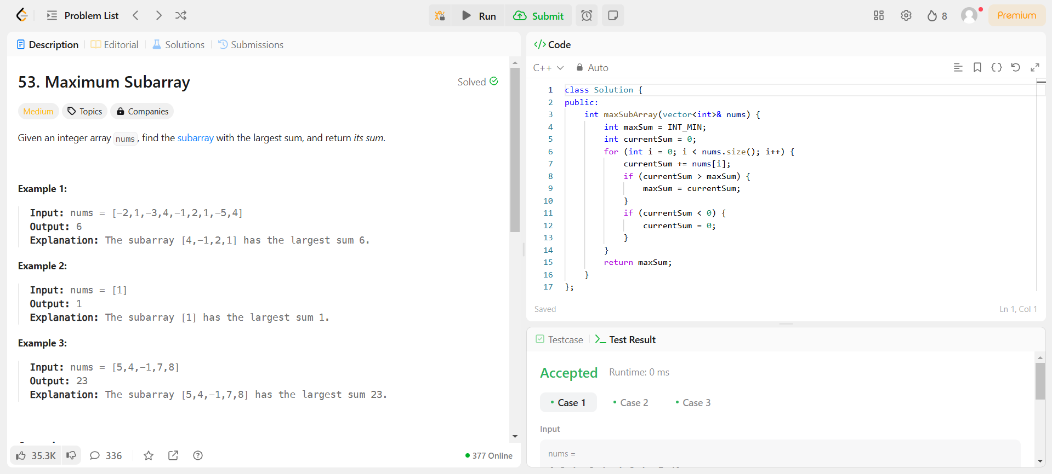

**240.**[**Search a 2D Matrix II**](https://leetcode.com/problems/search-a-2d-matrix-ii/description/)

class Solution {

public:

    bool searchMatrix(vector<vector<int>>& matrix, int target) {

        int n = matrix.size(), m = matrix[0].size();

        int row = 0, col = m - 1;

        while (row < n && col >= 0) {

            if (matrix[row][col] == target) return true;

            else if (matrix[row][col] < target) row++;

            else col--;

        }

        return false;

    }

};

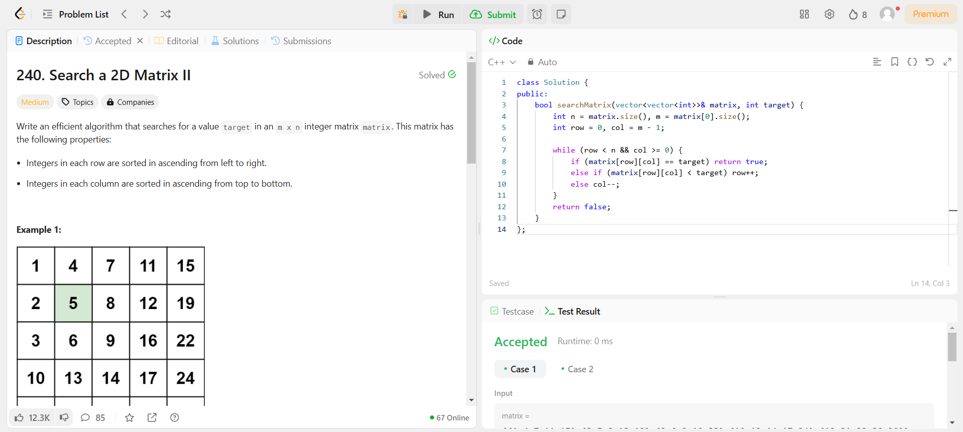

**372.**[**Super Pow**](https://leetcode.com/problems/super-pow/description/)

class Solution {

    const int base = 1337;

    int powmod(int a, int k)

    {

        a %= base;

        int result = 1;

        for (int i = 0; i < k; ++i)

            result = (result * a) % base;

        return result;

    }

public:

    int superPow(int a, vector<int>& b) {

        if (b.empty()) return 1;

        int last_digit = b.back();

        b.pop_back();

        return powmod(superPow(a, b), 10) * powmod(a, last_digit) % base;

    }

};

